1.Only badges shown. Add stickers and magnets too
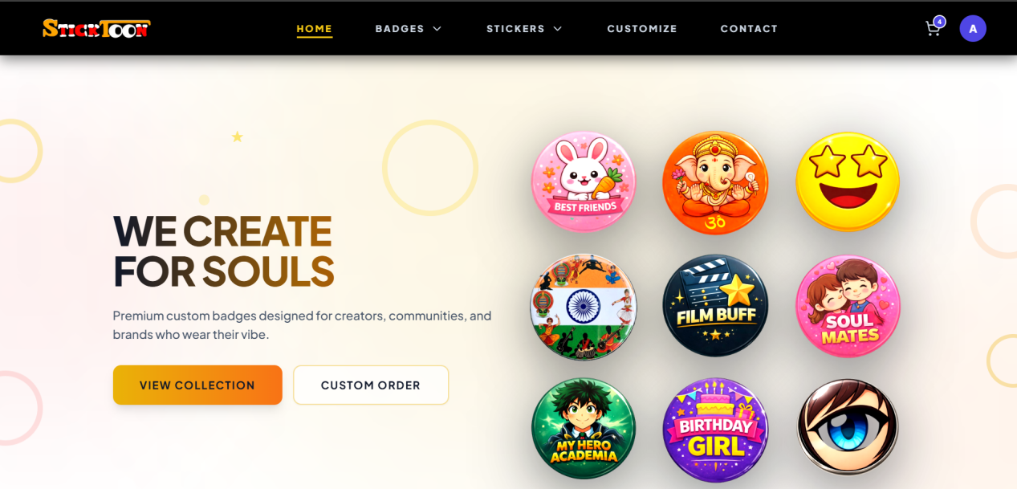
2.Clicking on a badge from home page should redirect to that specific badge. Show it with priority, if not available show out of stock.
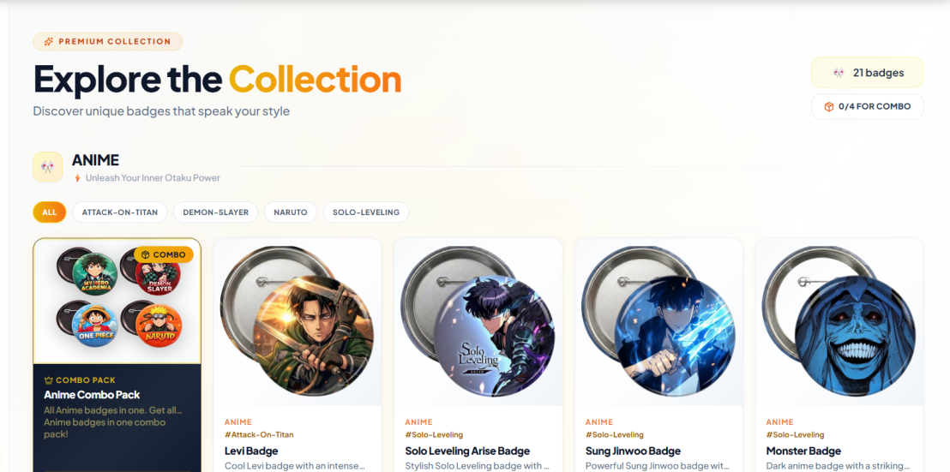
3.Adding to cart shows no difference. How do I know what I have added in cart without going to and fro to cart every time.

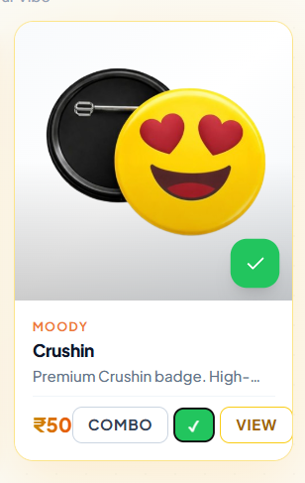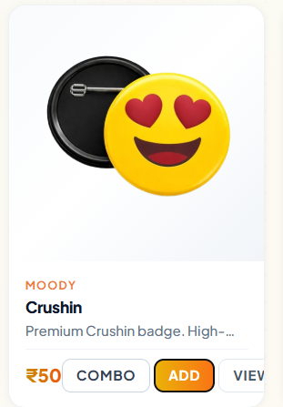
4.Scrolling issues many places.
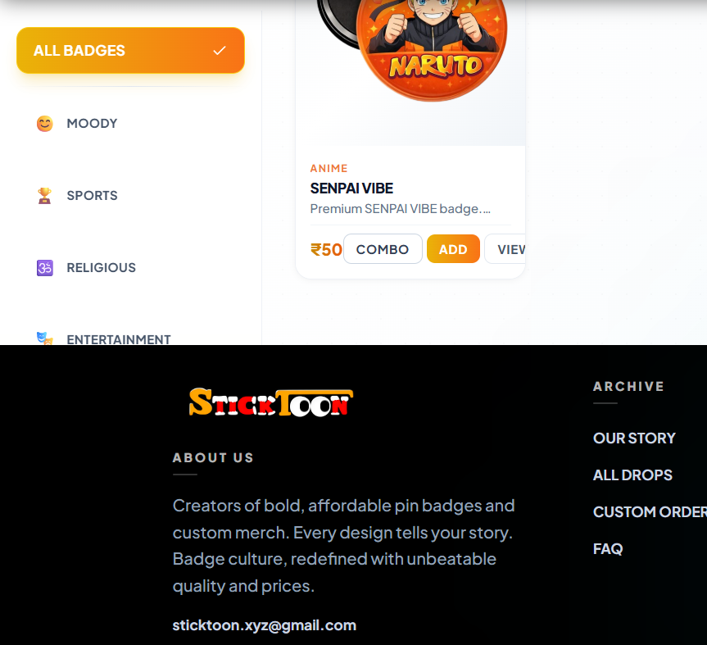
4.If I scroll on dashboard, the right side badges should not scroll up
5.Pin and magnet not differentiated properly. Customer wont know which has been selected.
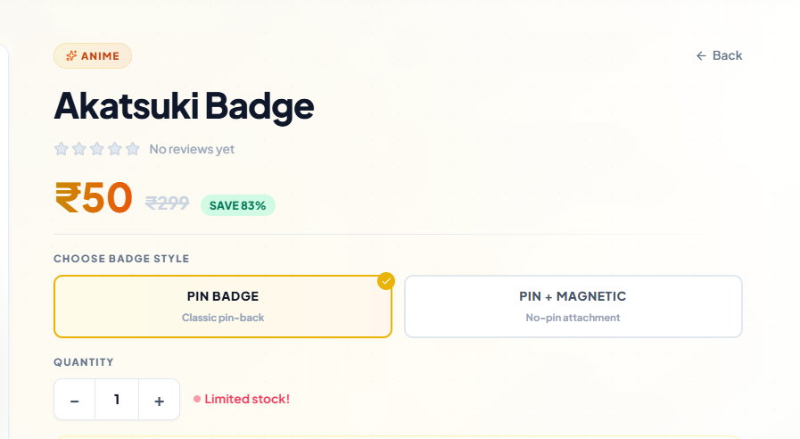
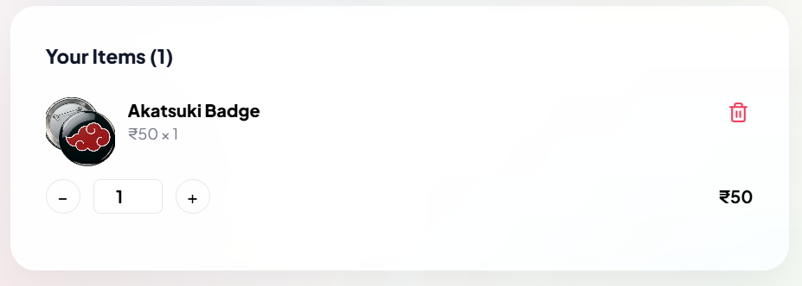
6.Clicking on place order from insta page directly places an order I insta chat.
7.Make a bot to ask if you want to place an order, how many quantity. Better to just redirect to website to that specific product rather than to open dm.
8.Keep dm for questions and inquiries not to place order. (how will insta dm orders be tracked?)
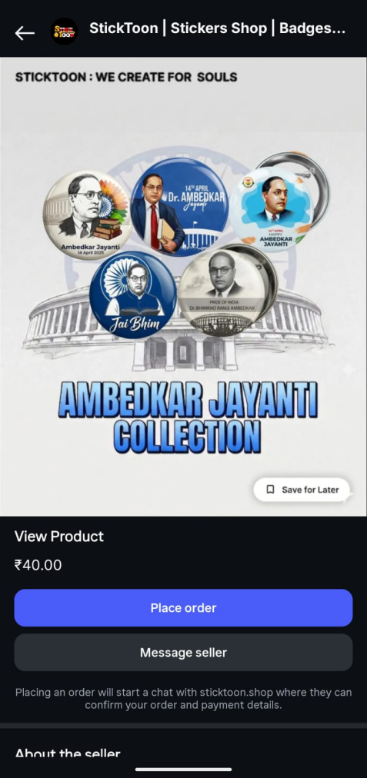
9.Stickers are not clickable. No description of length width quantity provided.
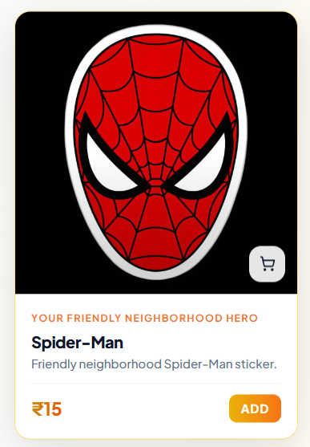
10.Custom orders difficult to customize on mobile. Takes up entire screen to know whats happening behind. Remove that zoom rotate option for mobile instead keep touch enabled editing.
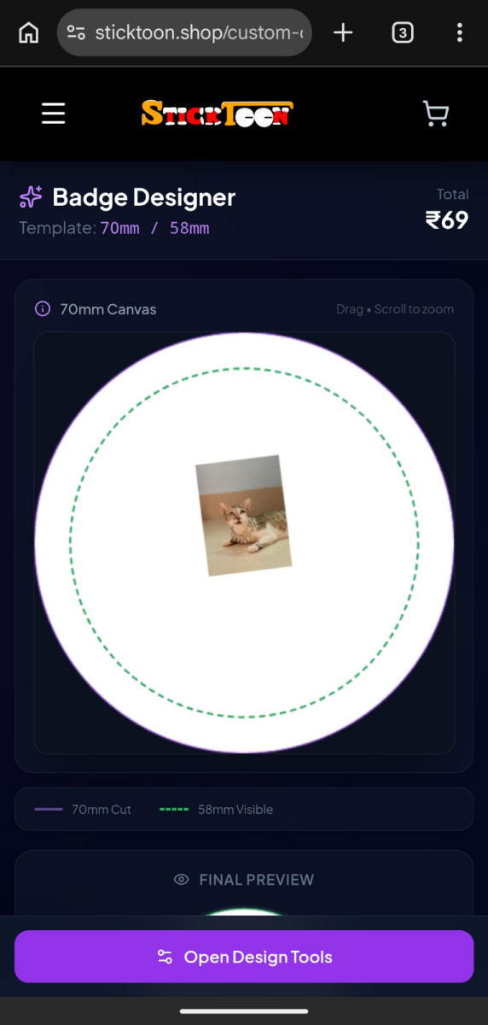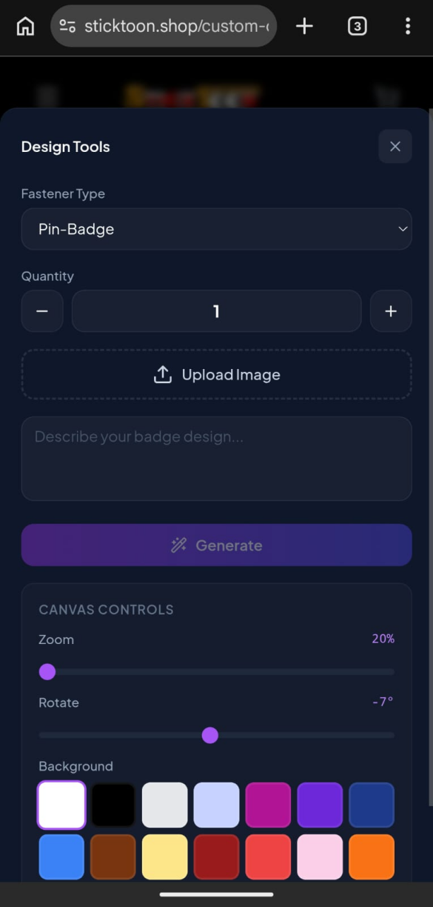
11.Why save for later on posts?
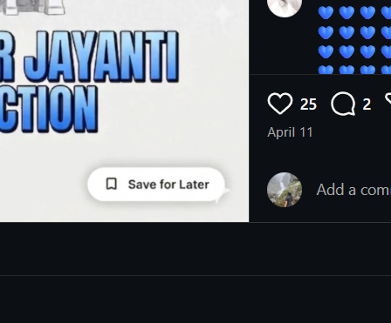
- Remove all user data (like custom image, stuff added to cart, address, autofilled email) from a users site if he/she logs out. Keep the site clean for use
13.If not clickable then why it pops up on hover? 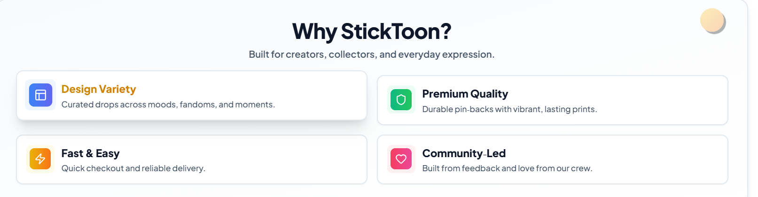
14.Even when I logged out my custom image is still there
15.No option to delete this image
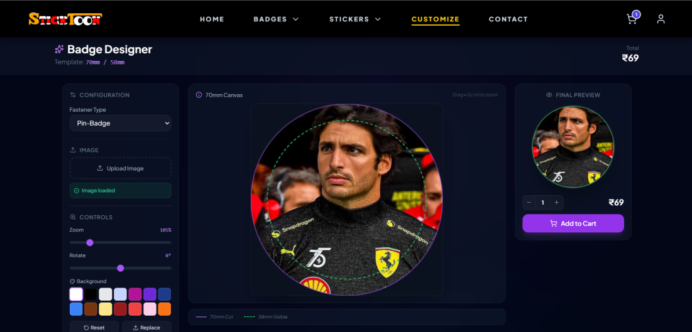
16.Soul’s? it should be souls

17.Even if I unsend the message the was sent after clicking place order, it still shows waiting for confirmation.
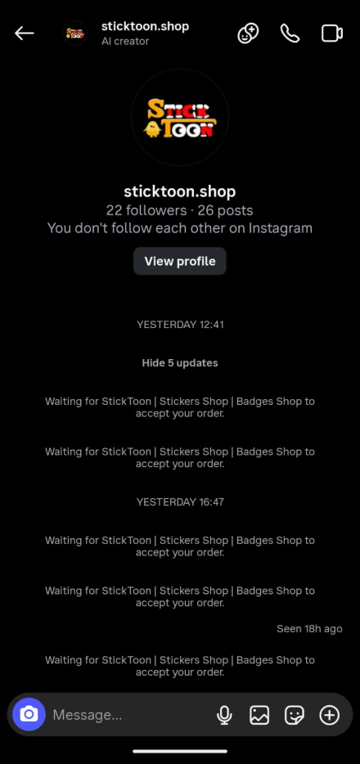
18.Add fridge magnets option

- Clicking on fridge magnets opens badges 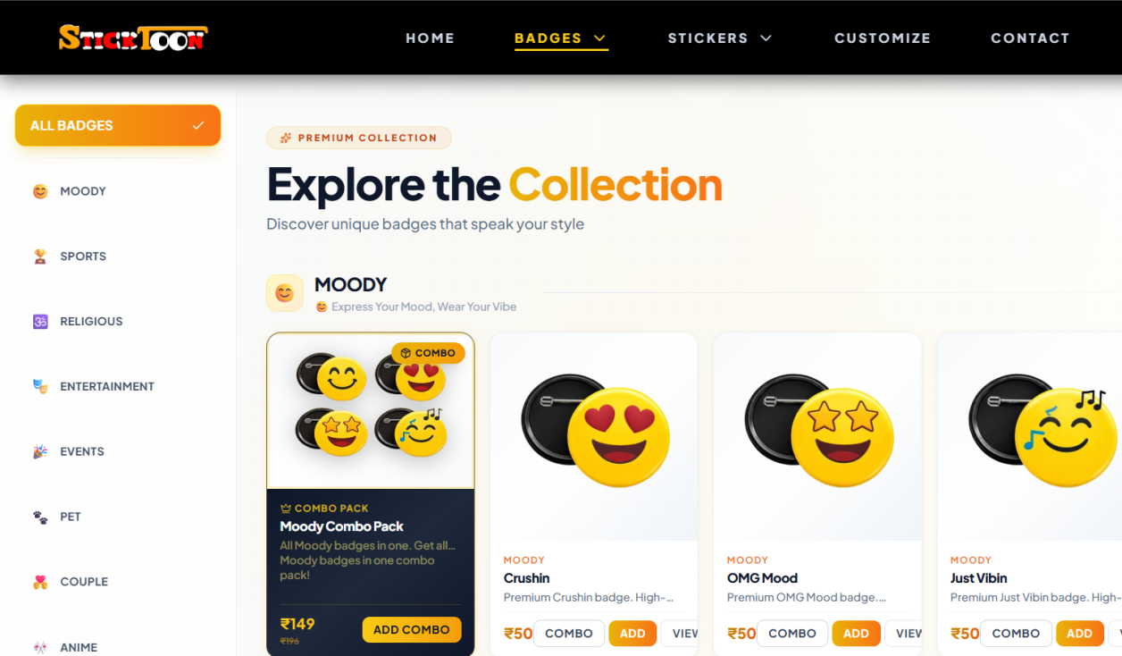
20.How many sticker? Size width??
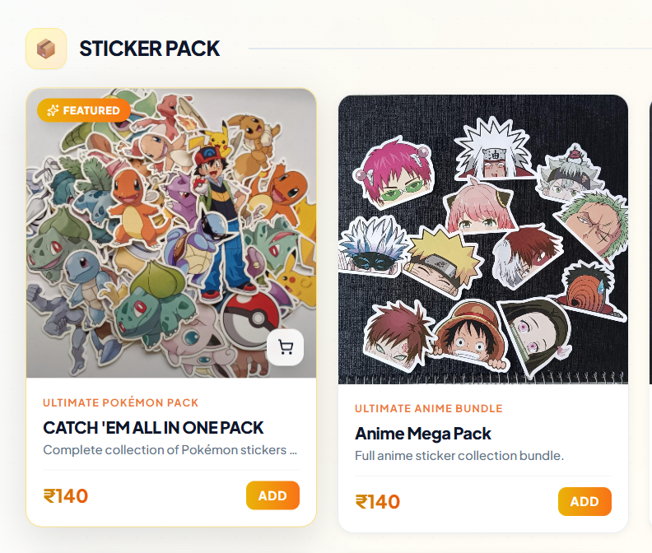
21.Bunch price same as single price??

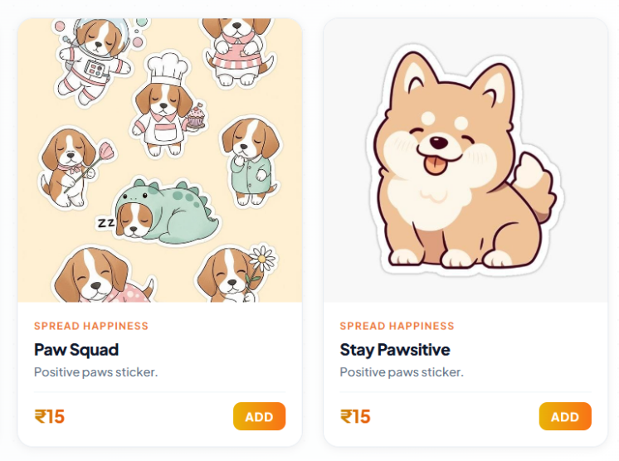
22.Edit products obstructs upper section
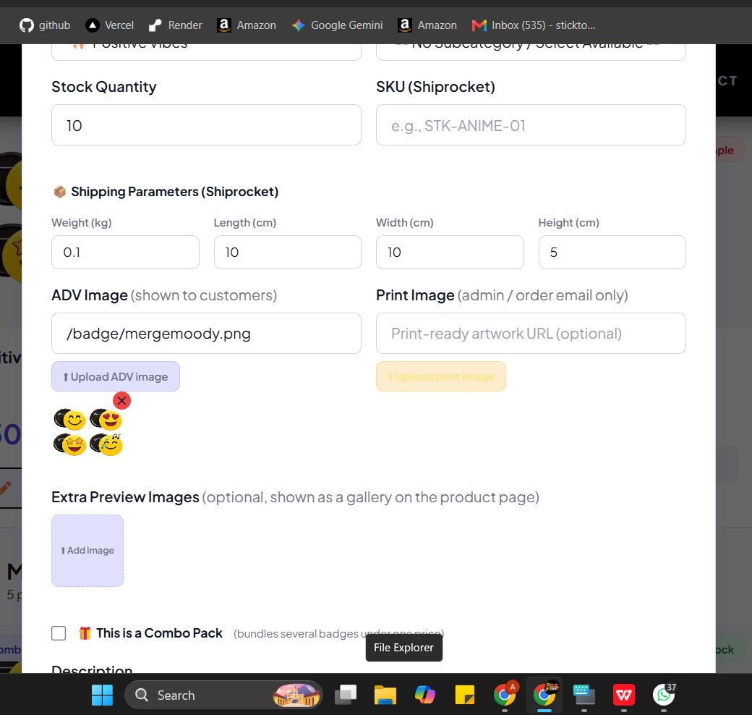

23.Add collapse option and search bar
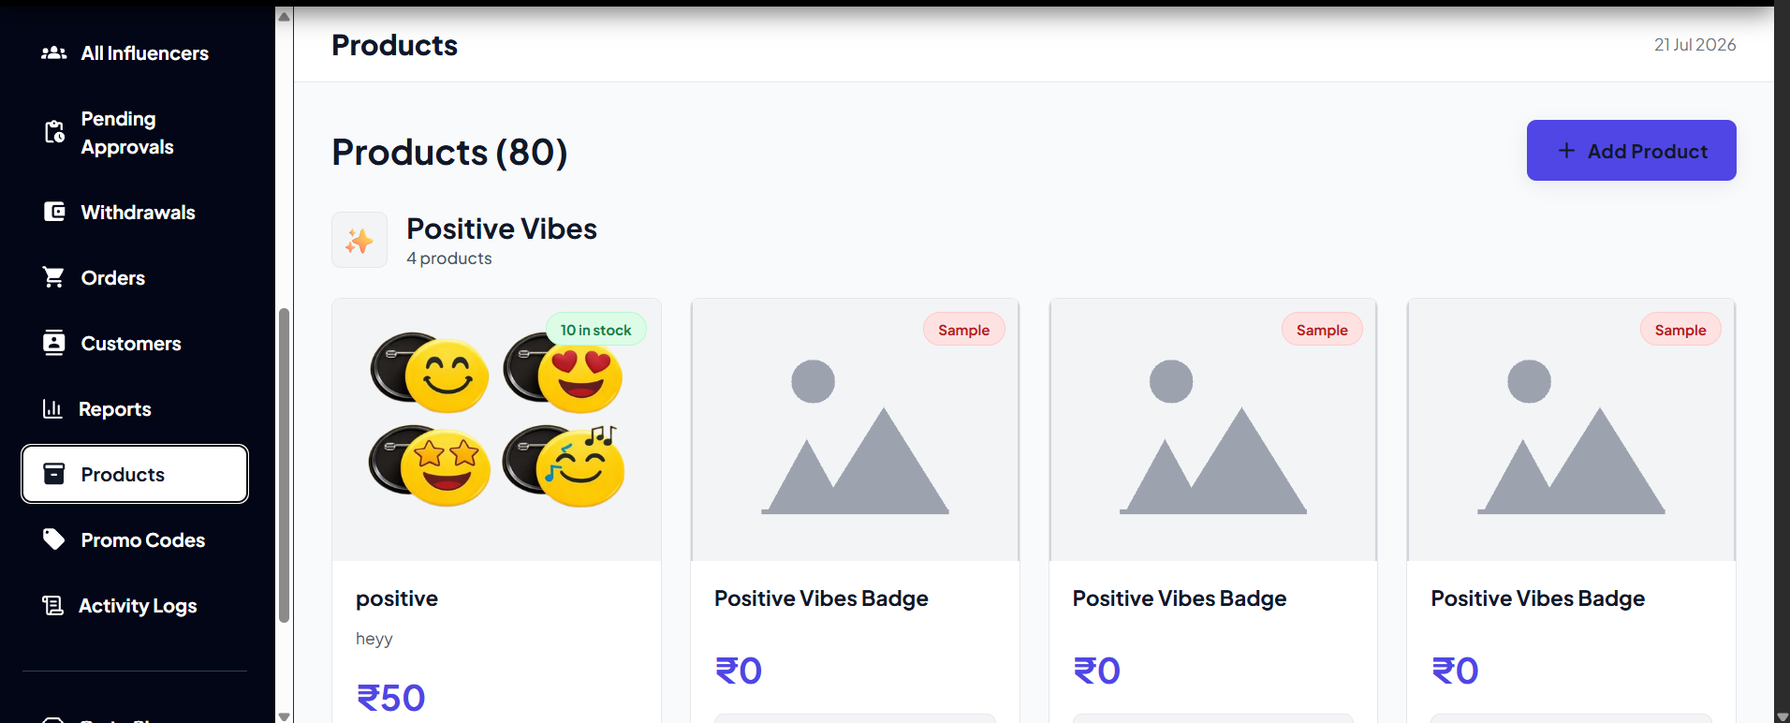
24. Different dashboard in some places?
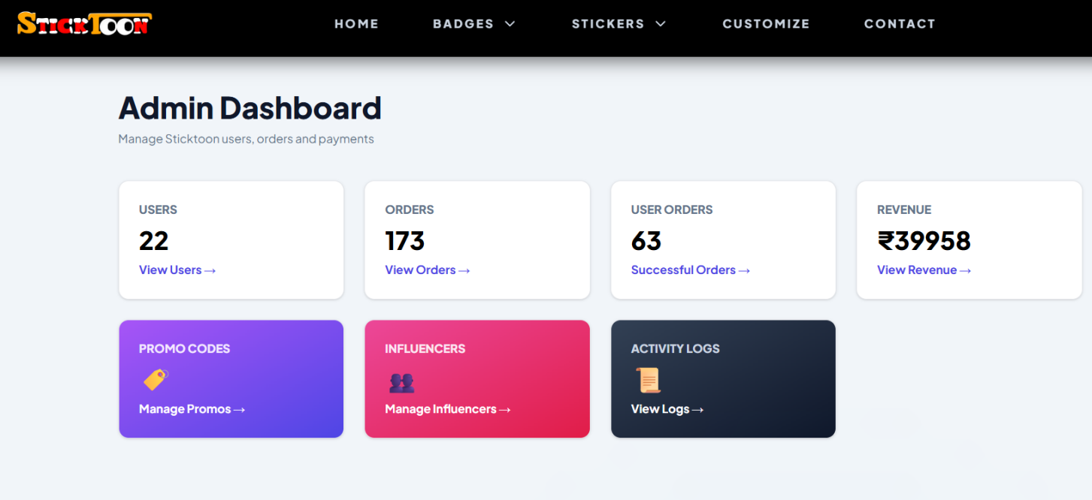
25.Different UI at different places
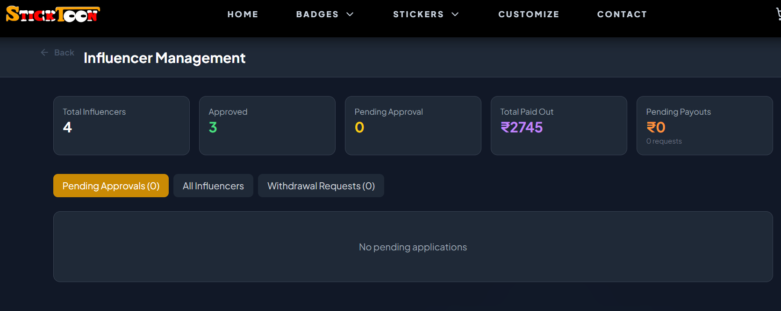
26.Add Back button everywhere in admin part atleast
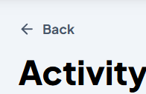
27.Tell customers magnets and badges are same but just comes with a magnet
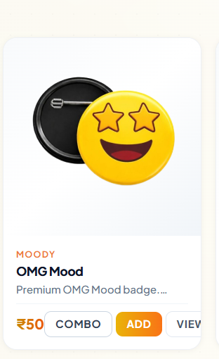
- Does not shows which address has been selected
- Haven’t logged in still proceeds to payment.
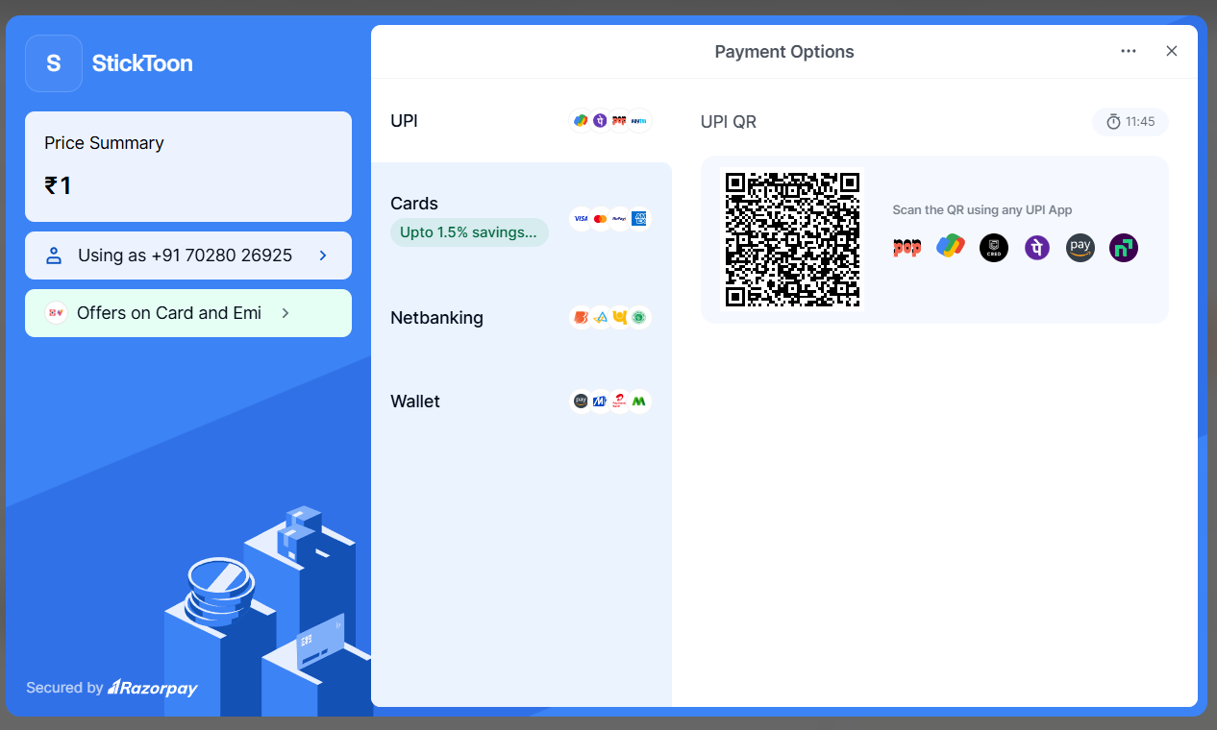
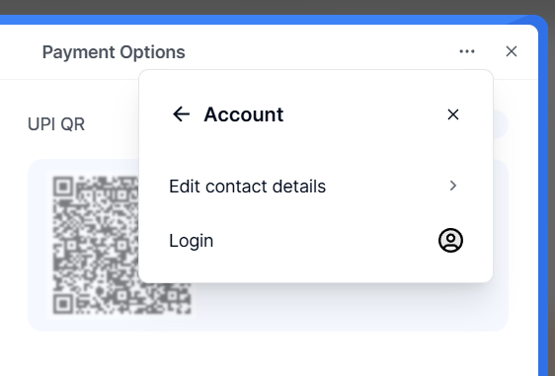
30.no option to save address.
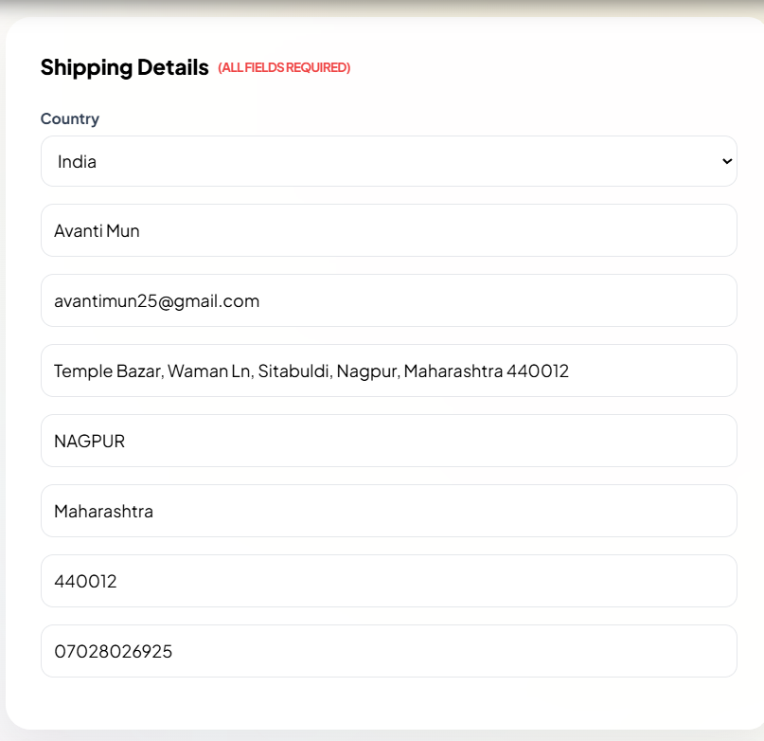
31.Does not shows address details. No way to know what address the order will be delivered to or to change or add new address.
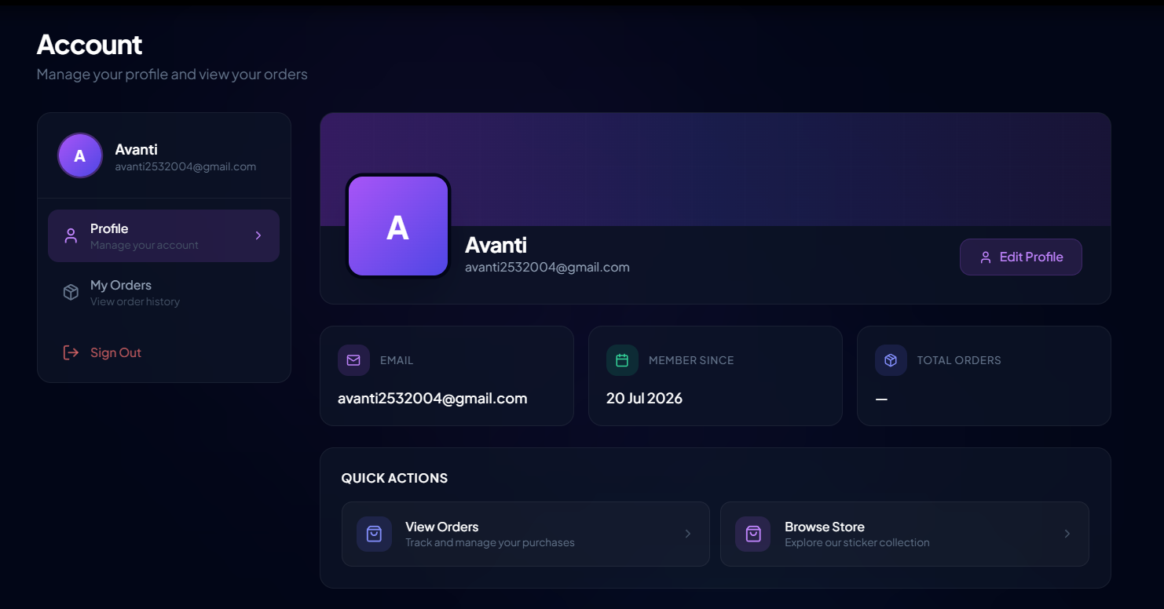
- What do I do with this? Cant complete payment cant delete this from order history
- Still shows after canceling my payment and not pacing order
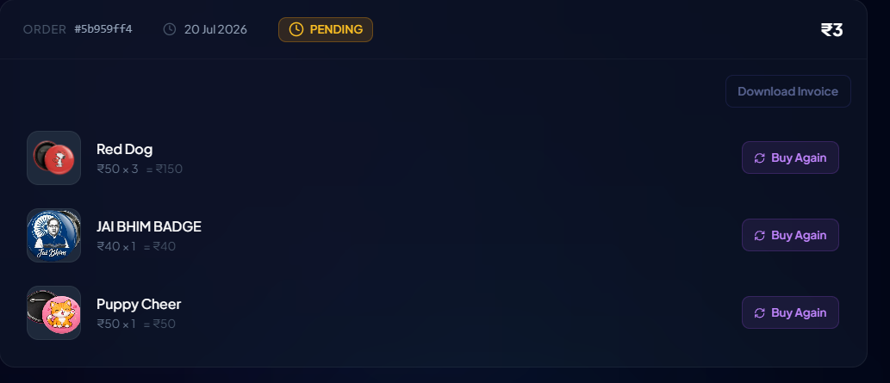
- My orders should redirect to my orders or remove it completely
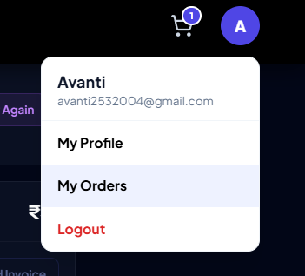
- If im already in my profile why is it giving me same options again?
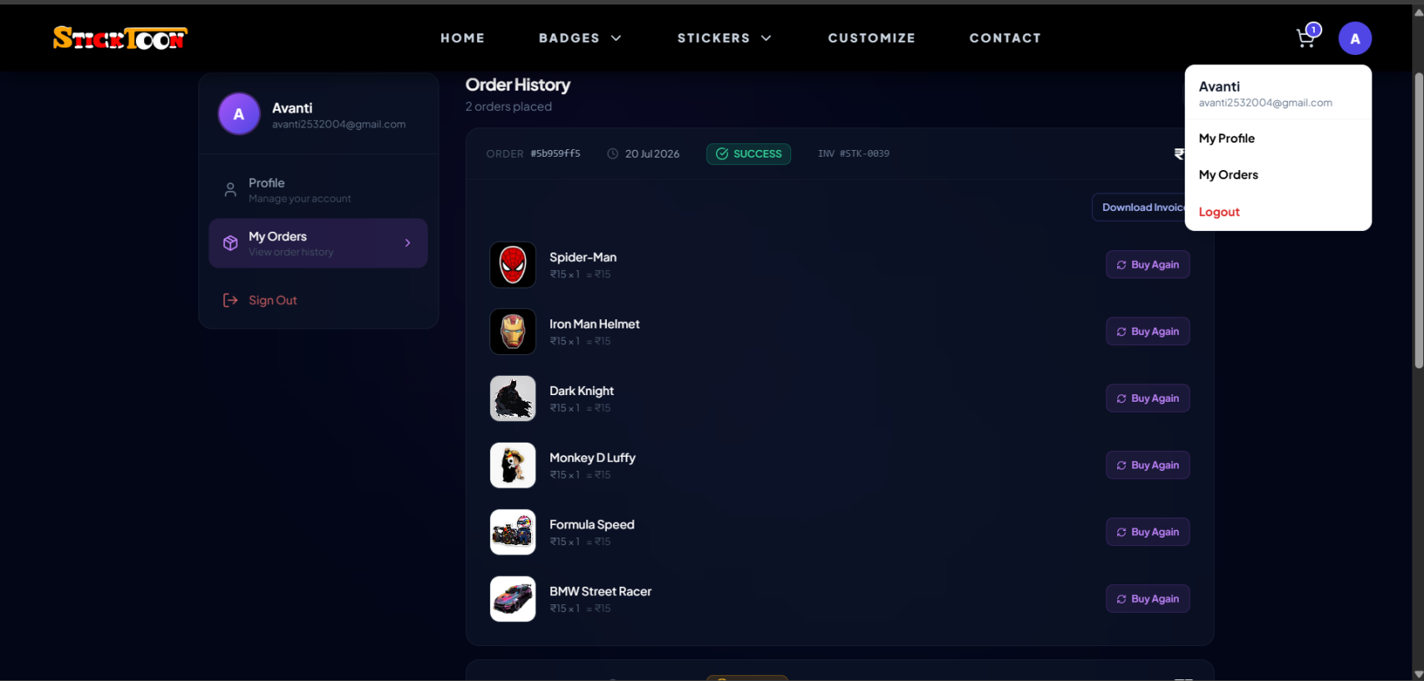
- How do I trackmy order from website?
- Shows in orders even after I canceled it
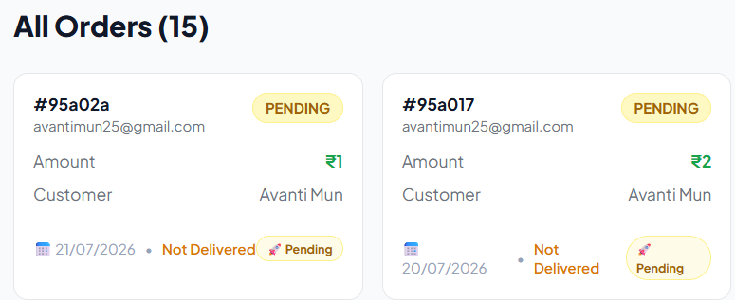
- Remove this upload photo option/ add toons to select as profilr pic
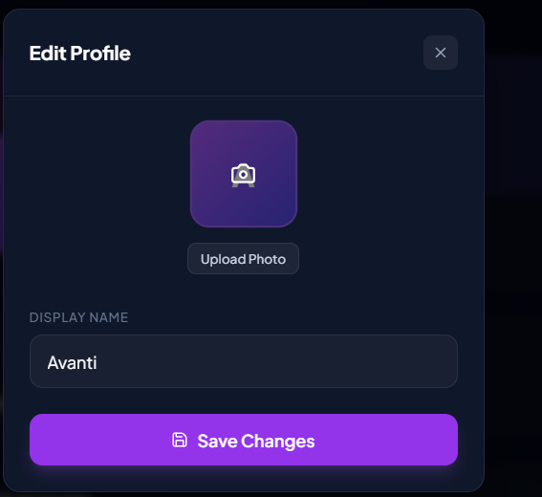
- Wrong data. My amount without coupon was 90, with is 2, but shows me as top customer with rs197.
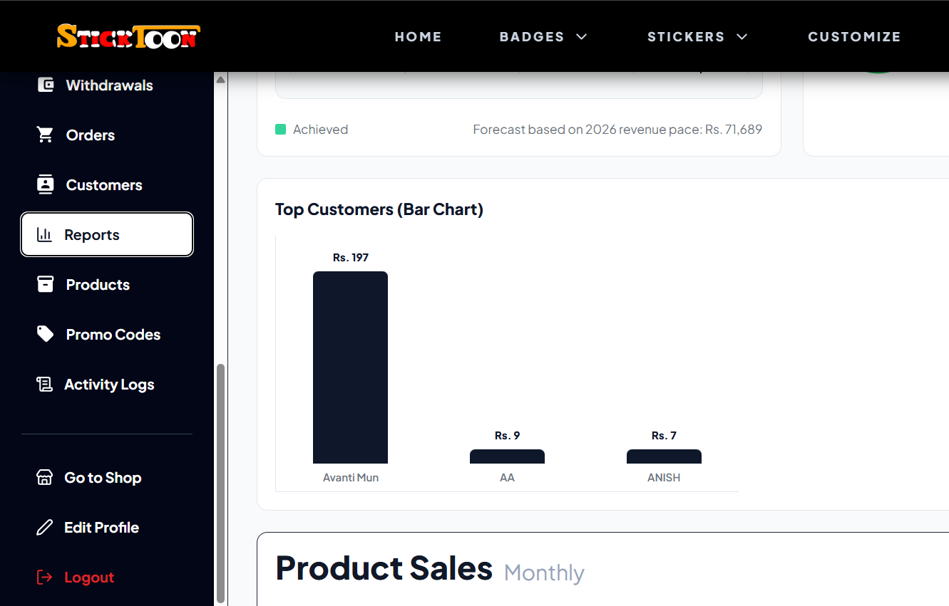
- Add sorting for delivered/not delivered
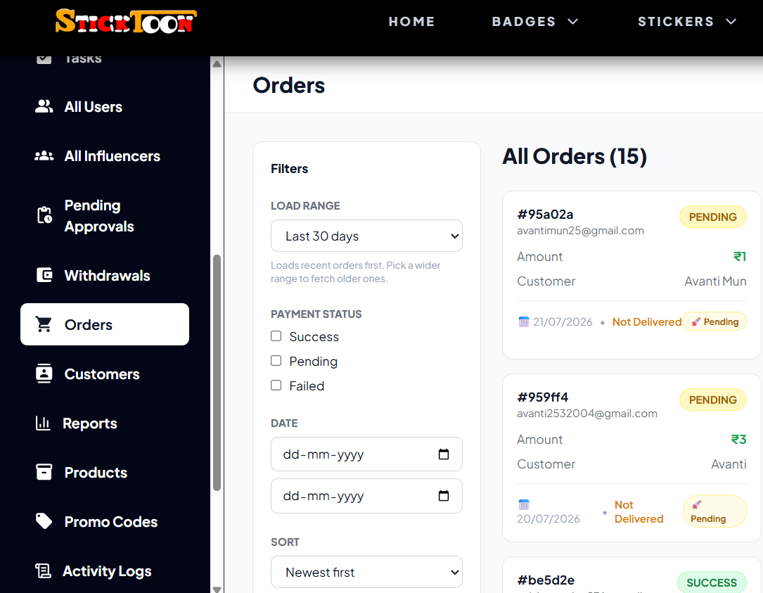
- New category option
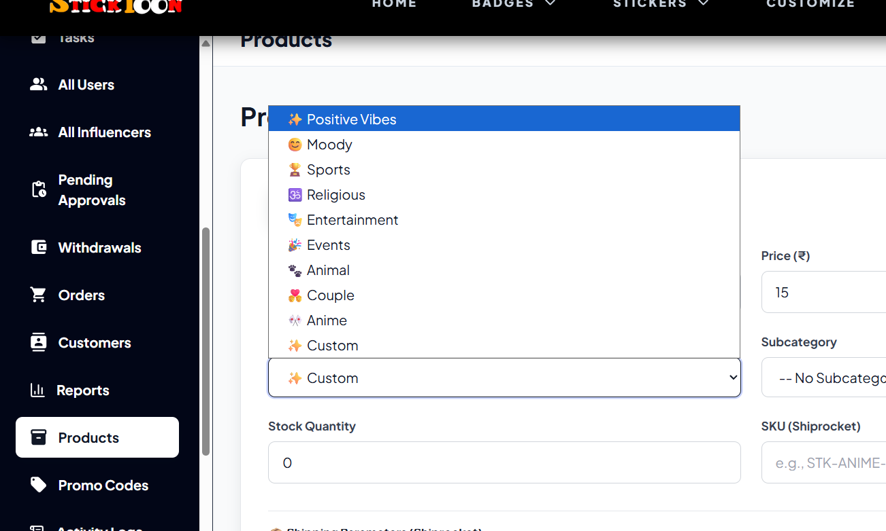
- Can only add badge.
- Only badges are visible in products
- Added product reflects immediately in site but deleting takes time. Had to close the site for the product to be deleted from site. Yet it was still in cart. Placing order showed out of stock though.
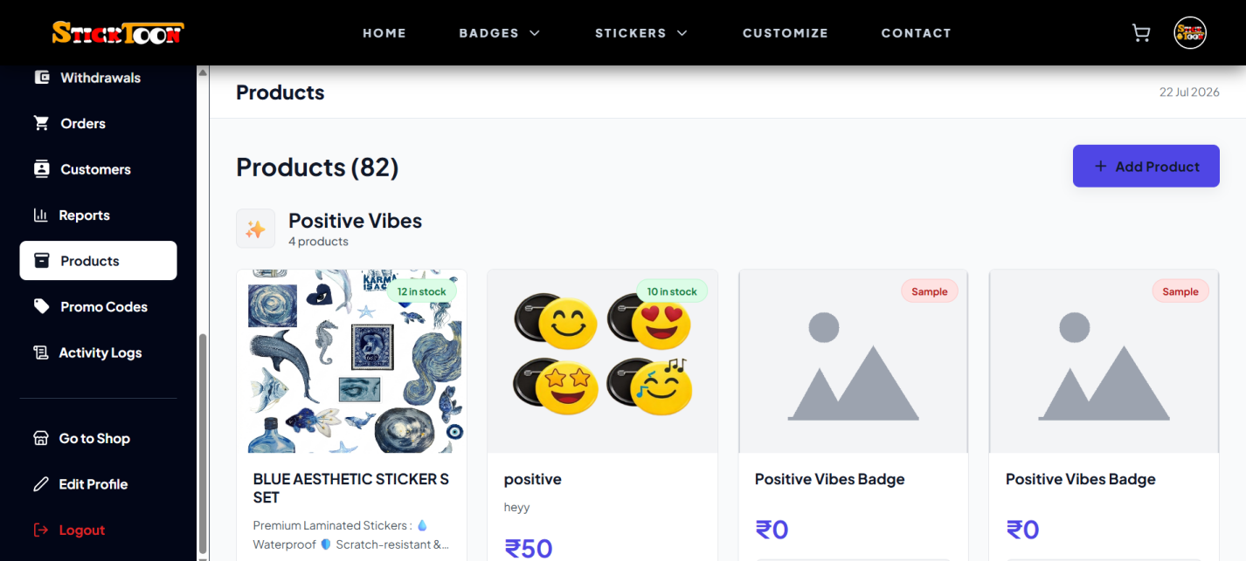
- Add search bar
- Make this clickable in cart
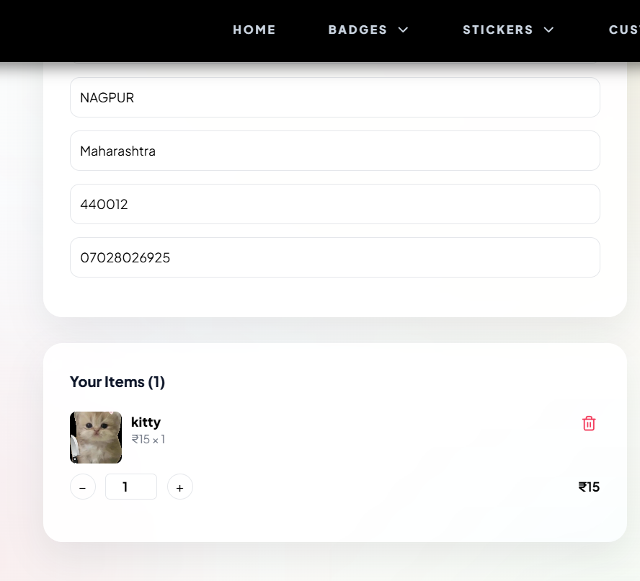
- Catalogue isn't saved in Crm also invoice
- Influencers pending approval not reflected
- Editing profile in admin dashboard difficult
- Can't delete cant edit
- Editing profile from user to influencer drops id at the last
- SLA history not saved
- Who sends msgs on tickets?
- Filter for sorting in every list
- In notification how we get leads?
- How to know how many ticket id i raised
- Tracking ticket id for customer
- Date for support sla when it came when it is due
- Refund policy and stuff in profile
- Support list should collapse into a list
- Resolved SLA should be shown to customer
- A final email to customer telling ticket resolved
- What's entity id in create task?
- Select assignee has user name list(where it came from)
- User should have an option to be a team member
- Those team members and admin could be in assignee (task section)
- Name besides task (who it is assigned to)
- Quotation number in catalogue (number of quotation should have different numbers /1 /2)
- Import product should have better sorting in catalogue
- Add item in catalogue, when jumping on new page, rest of the space is empty
- Fix the footer at the end of every page
- Final pricing only at last page at down not somewhere in between the page
- Remove Custom advantage (add description that you can add customized products) free space
- Catalogue should be saved when we send it
- Footer details should be visible to edit properly
- Lead - send - catalogue. Should be a button to attach it to the email and open email to edit and send
- Option to save or replace the catalogue every time(essential to proceed further)
- Custom catalogue and invoice should have list of existing ones
- And send button should have a option to select how many leads to sent it to
- Send button should open email to edit the email as per requirement
- Deals - show details properly
- 'Add' option in currency (deal- quotation)
- Rs symbol in front of rs
- Select delivery within 2-5, 5-7, 7-14 days.....
- International - 5-7 working days, 7-14, 15-30
- If the product is delayed than selected time period it won't be on company side
- Find out insurance amount percentage with respect to in country and outside the country
- Add insurance price in bill (checkbook option)(if anything happens to product in transportation, company will provide it for free. Percentage of insurance should be editable by admin)
- If lost then we will decide the percentage of insurance and will bear loss and sent the product at manufacturing price including transportation cost
- Expected cost, what was actually received, or decline in cost
- Every company in deals should have a detailed panel when clicked storing every detail inside (show only necessary outside)
- Add sorting in deals - date, amount, frequency, quantity, alphabetical
- Send opinion in deal too
- Remove admin sign up button and influencer from home page
- Once account created, everybody should be able to sign in from the same page. No need for different portal for different people to sign in.
- Add ‘want to sign up as an influencer’ option in sign up page
Influencers -
- How is Money added? What is pending? How is the money in pending managed?
- Pending data should not be reflected unless it's from our side(we have to pay him that amount)
- Replace dollar with whatever currency influencer chooses
- He should see total commission not total order amount in orders list. Total earning should be at top
- Available withdrawal amount (how is it calculated)
- Paid should be green (pending, rejected, paid add all three)
- Remove promo code from withdrawal
- Note?
- Details of influencer should be checked thoroughly before saving
- Give bank list to select from
- Give home bank branch too
- Influencer request accepted but can't log in, no email received
- Should be able to access different account from different tabs
- Authentication in influencer login
- Can't verify influencer details before accepting
- Rejected goes in pending
- Influencer should add details beforehand for it to be checked before starting the account
- Instagram Account should be checked (clickable that redirects to the account to verify)
- Pending approvals should not be in influencer they should be in rejected
- Withdrawing request not working
- Order pushed to shiprocket but no record
- New orders should show number of orders as a number floating above it(like new msgs on Instagram icon)
- Manual push for shiprocket logo needs to be changed
Reports-
- Graph in product sales
- Order failed?
- Business report data is not correct
- Graph should have description (daily, monthly, annually)
- Ordered - above count should be static
Promo code-
- Option to Select influencers to whom the created or new created code should be given(should reflect in their dashboard)
- Also to remove from that influencer
- Show influencer name/id jisko code diya hai
- Show inactive code count too
- Influencer management is on different dashboard and not in main dashboard
- Promo code dashboard buttons should be clickable to sort
- Remove the home, badges, sticker from above in admin panel instead keep ‘go to shop’ that redirects to shop
- Don't keep 'my order' and stuff in three different places on a single page
- For admin logging in should open admin panel not site.
- For users, clicking on profile should open profile directly which will include orders, refund policy etc. inside that page
- Things to add in profile -
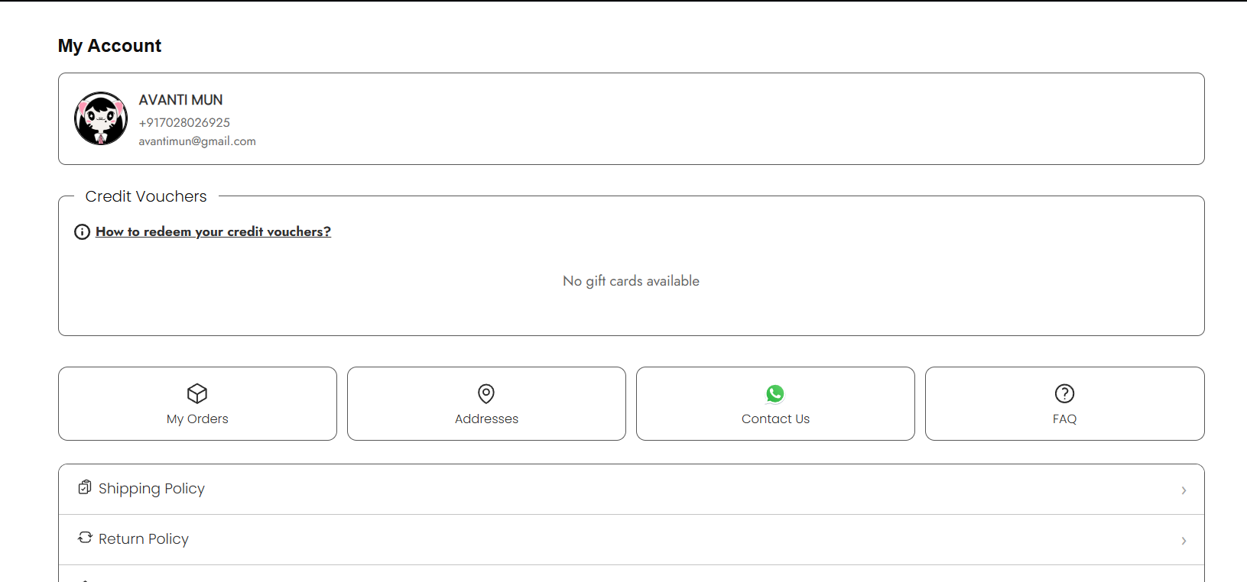
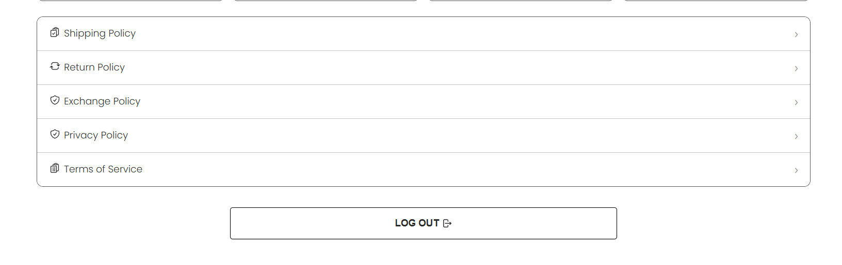
- Who is managing this ?
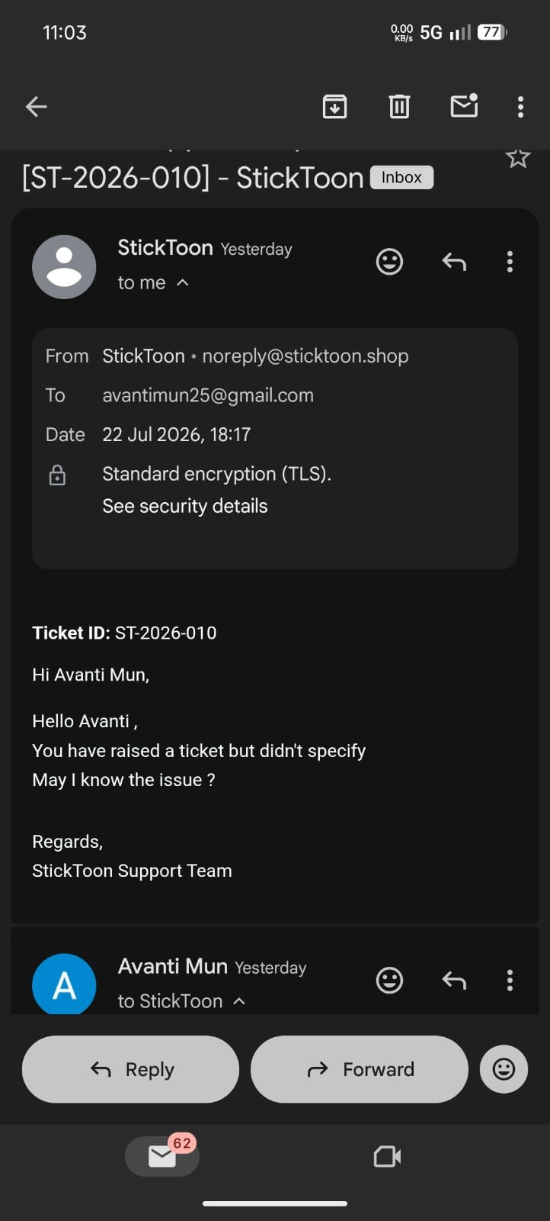
- Edit the cart to be shown on right side every time a product is added. Even when clicked on the cart icon without anything in cart.
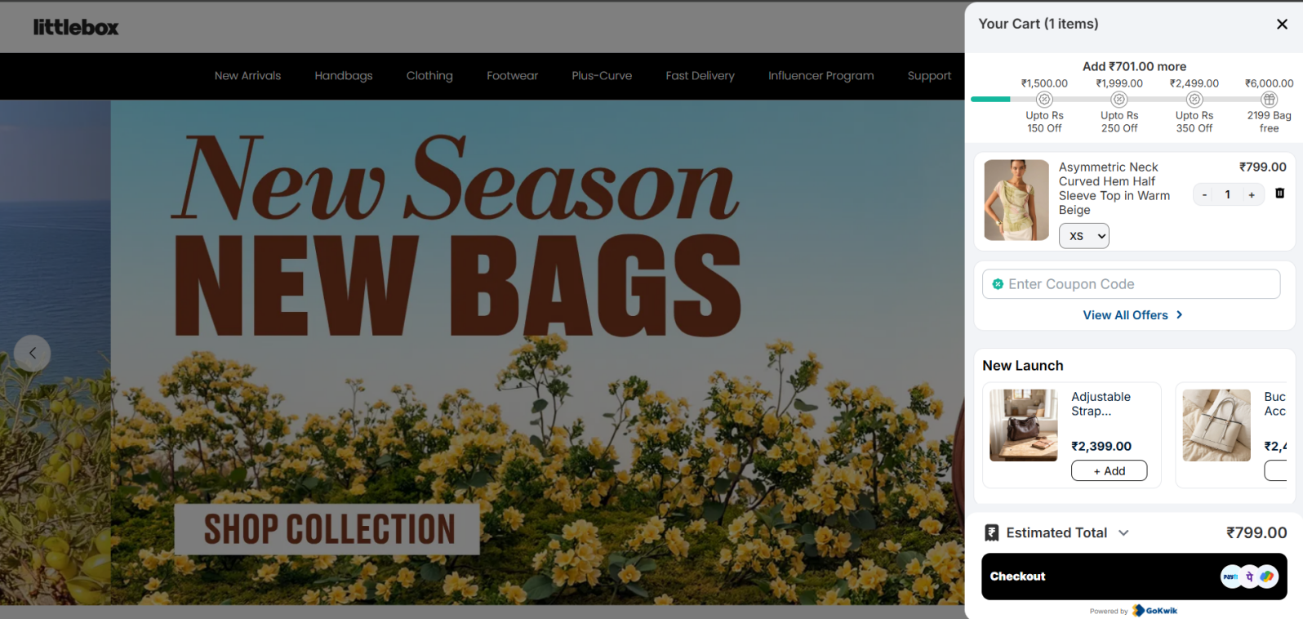
- The dashboard should be on top like this with subcategories not on left side.
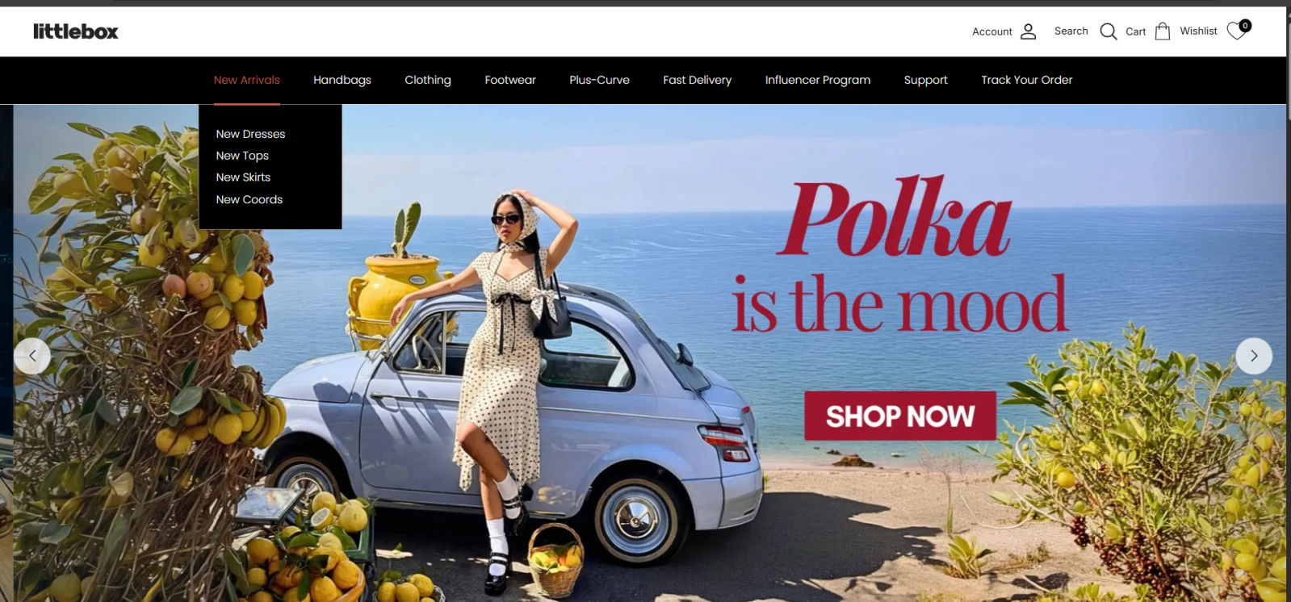
- The footer should be like this at the end even when im browsing a specific product.
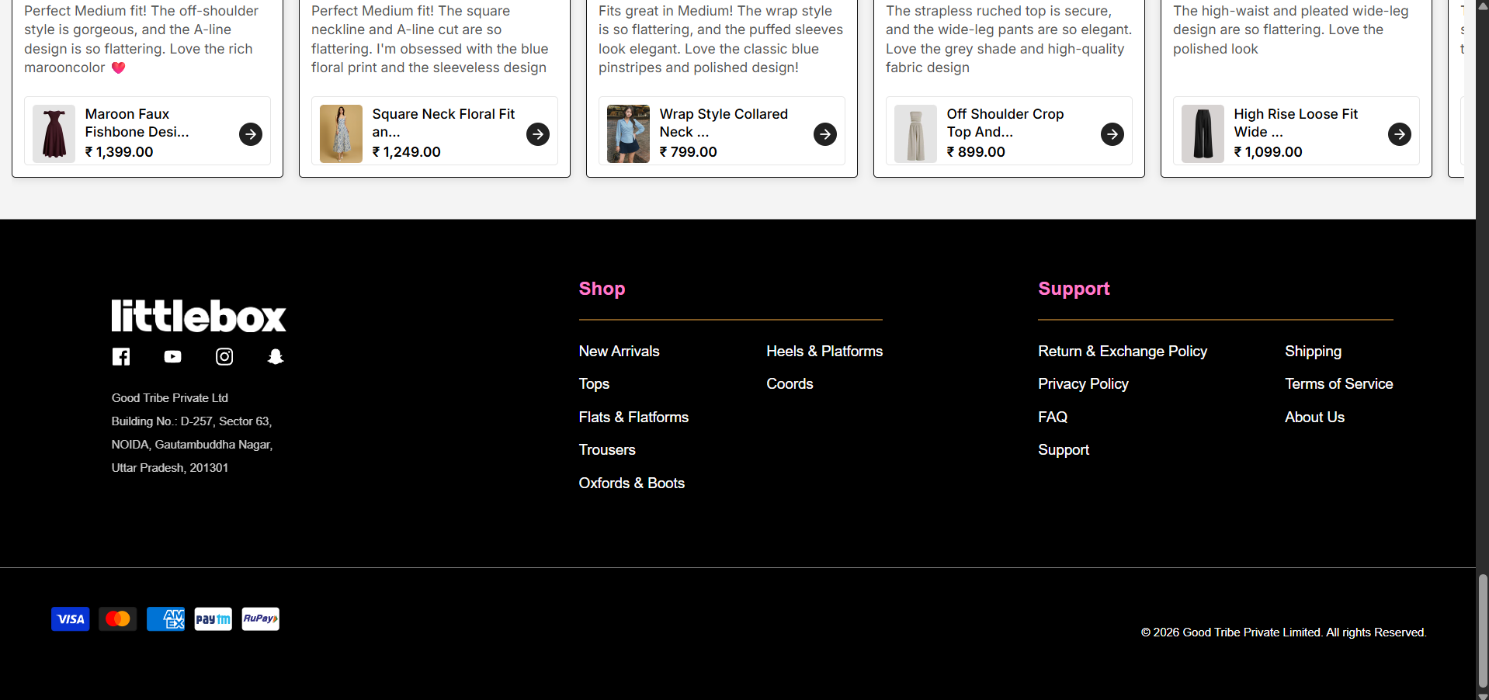
- Save the address and remove this from the cart from the second time.
- When a person clicks on checkout (refer to the cart image attached above), check if he’s logged in, if yes, show selected default address (option to select, change, add new, edit) and payment option. If not logged in, redirect to signup/login page including address( address in sign up page) then to payment options.
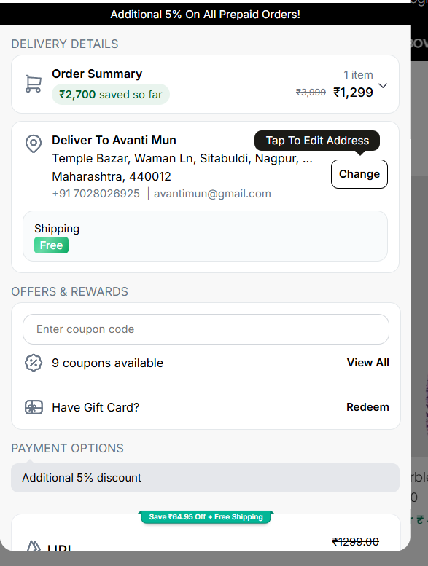
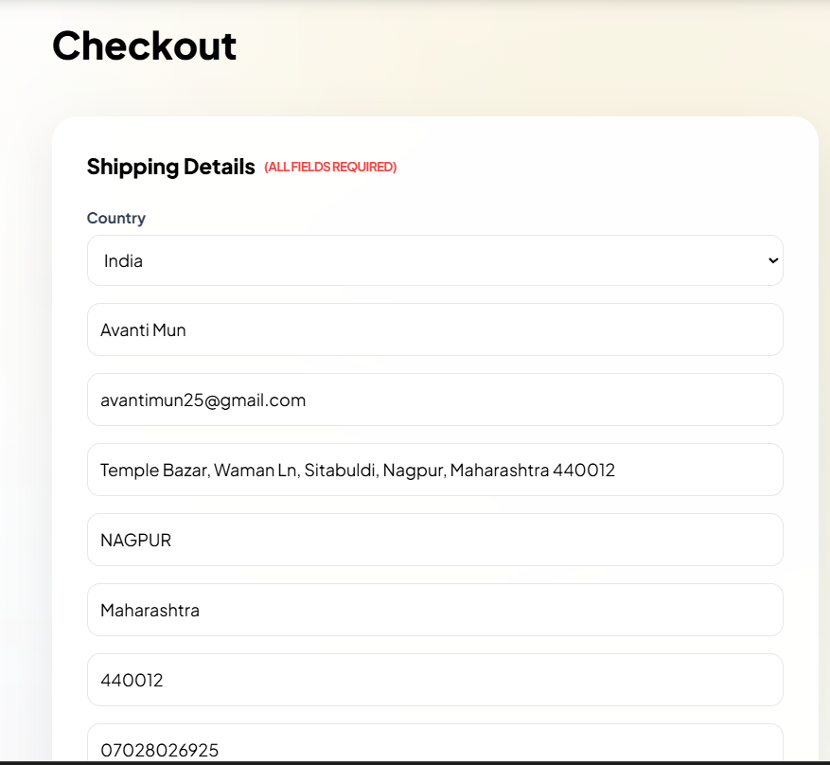
- Give option to select address, add a new address, edit existing address. Show what address is selected by default.
- don’t keep these hover effect if they are not clickable
- Save from site to drive directly? Catalogue, invoice, quotation
- Remove fridge magnet option from site

